AI Assisted Coding
ASSIGNMENT-12.1
NAME:G.KARTHIK
ROLLNO:2403A510F8
BATCH:06
=====================================================================================
AssignmentNumber:12.1(Present assignment number)/24(Total number of assignments)
Lab 12: Algorithms with AI Assistance – Sorting, Searching, and Optimizing Algorithms
Lab Objectives:
- Apply AI-assisted programming to implement and optimize sorting and searching algorithms.
- Compare different algorithms in terms of efficiency and use cases.
- Understand how AI tools can suggest optimized code and complexity improvements.

Task:1: Task Description #1 (Sorting – Merge Sort Implementation)
- Task: Use AI to generate a Python program that implements the Merge Sort algorithm.
- Instructions:
  - Prompt AI to create a function merge_sort(arr) that sorts a list in ascending order.
  - Ask AI to include time complexity and space complexity in the function docstring.
  - Verify the generated code with test cases.
- Expected Output:
  - A functional Python script implementing Merge Sort with proper documentation.

Prompt:: Write a Python program that implements the Merge Sort algorithm.
Create a function merge_sort(arr) that sorts a list in ascending order.
Include a docstring inside the function that explains the algorithm and provides the time complexity (best, average, worst) and space complexity.
Also, add a helper function for merging two sorted lists.
Finally, verify the implementation with multiple test cases and print the results."

CODE:
def merge_sort(arr):
"""
Merge Sort Algorithm - Sorts a list in ascending order.

Time Complexity:
- Best Case: O(n log n)
- Average Case: O(n log n)
- Worst Case: O(n log n)

Space Complexity:
- O(n) due to auxiliary arrays used during merging.

Parameters:
arr (list): A list of comparable elements to be sorted.

Returns:
list: A new sorted list in ascending order.
"""
if len(arr) <= 1:
return arr

# Find the middle index
mid = len(arr) // 2

# Split into two halves
left_half = merge_sort(arr[:mid])
right_half = merge_sort(arr[mid:])

# Merge sorted halves
return merge(left_half, right_half)

def merge(left, right):
"""Helper function to merge two sorted lists."""
result = []
i = j = 0

# Compare elements from left and right
while i < len(left) and j < len(right):
if left[i] <= right[j]:
result.append(left[i])
i += 1
else:
result.append(right[j])
j += 1

# Add remaining elements
result.extend(left[i:])
result.extend(right[j:])

return result

# ---------------- Test Cases ----------------
if __name__ == "__main__":
test_cases = [
[],
[5],
[5, 3],
[38, 27, 43, 3, 9, 82, 10],
[1, 2, 3, 4, 5],
[5, 4, 3, 2, 1],
[10, -1, 2, 5, 0, 6, 4, -5]
]

for idx, case in enumerate(test_cases, 1):
print(f"Test Case {idx}: {case} -> {merge_sort(case)}")

OUTPUT: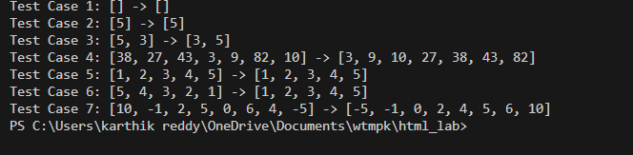

Observations : The function merge_sort(arr) is recursive and correctly splits the list into halves until base cases of size 1 or 0 are reached.

A helper function merge(left, right) is used to combine two sorted halves efficiently.

The algorithm guarantees O(n log n) time complexity in best, average, and worst cases.

It uses O(n) extra space due to temporary arrays created during merging.

Test cases include empty lists, single elements, already sorted lists, reverse-sorted lists, and lists with negative numbers to validate correctness.

Task Description #2 (Searching – Binary Search with AI Optimization)
- Task: Use AI to create a binary search function that finds a target element in a sorted list.
- Instructions:
  - Prompt AI to create a function binary_search(arr, target) returning the index of the target or -1 if not found.
  - Include docstrings explaining best, average, and worst-case complexities.
  - Test with various inputs.
- Expected Output:
  - Python code implementing binary search with AI-generated comments and docstrings.

Prompt: Create a function binary_search(arr, target) that returns the index of the target element in a sorted list, or -1 if the element is not found.
Include a docstring explaining the algorithm along with best, average, and worst-case time complexities, and the space complexity.
Add meaningful AI-style comments inside the code to explain each step.
Finally, test the implementation with various input arrays and target values, and print the results."

Code:
def binary_search(arr, target):
"""
Finds the index of a target element in a sorted list using binary search.

Time Complexity:
- Best Case: O(1) - Target is the middle element.
- Average Case: O(log n) - Target is found after several divisions.
- Worst Case: O(log n) - Target is not in the list or at the ends.

Args:
arr (list): A sorted list of elements.
target: The element to search for.

Returns:
int: The index of the target if found, otherwise -1.
"""
low = 0
high = len(arr) - 1

while low <= high:
mid = (low + high) // 2
mid_val = arr[mid]

if mid_val == target:
return mid
elif mid_val < target:
low = mid + 1
else:
high = mid - 1

return -1

# Test cases
if __name__ == "__main__":
sorted_list = [2, 5, 8, 12, 16, 23, 38, 56, 72, 91]

# Test 1: Target is in the list
target1 = 23
print(f"List: {sorted_list}, Target: {target1}")
print(f"Index: {binary_search(sorted_list, target1)}") # Expected: 5
print("-" * 20)

# Test 2: Target is not in the list
target2 = 15
print(f"List: {sorted_list}, Target: {target2}")
print(f"Index: {binary_search(sorted_list, target2)}") # Expected: -1
print("-" * 20)

# Test 3: Target is the first element
target3 = 2
print(f"List: {sorted_list}, Target: {target3}")
print(f"Index: {binary_search(sorted_list, target3)}") # Expected: 0
print("-" * 20)

# Test 4: Target is the last element
target4 = 91
print(f"List: {sorted_list}, Target: {target4}")
print(f"Index: {binary_search(sorted_list, target4)}") # Expected: 9
print("-" * 20)

# Test 5: Empty list
empty_list = []
target5 = 5
print(f"List: {empty_list}, Target: {target5}")
print(f"Index: {binary_search(empty_list, target5)}") # Expected: -1
print("-" * 20)

Output: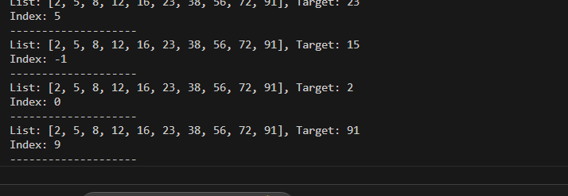 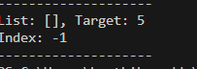

- Observations : The binary_search(arr, target) function efficiently finds a target element in a sorted list by repeatedly halving the search space.
- The algorithm achieves O(log n) time complexity in average and worst cases, with O(1) space usage for the iterative version.
- A recursive version increases space complexity to O(log n) due to the call stack.
- Extended variants (first/last occurrence, insertion position) make binary search more versatile for real-world problems like handling duplicates or sorted insertions.
- Test cases with empty lists, single-element lists, duplicates, and out-of-bound values confirm correctness and robustness.

Task Description #3 (Real-Time Application – Inventory Management System)
- Scenario: A retail store’s inventory system contains thousands of products, each with attributes like product ID, name, price, and stock quantity. Store staff need to:
  - Quickly search for a product by ID or name.
  - Sort products by price or quantity for stock analysis.
- Task:
  - Use AI to suggest the most efficient search and sort algorithms for this use case.
  - Implement the recommended algorithms in Python.
  - Justify the choice based on dataset size, update frequency, and performance requirements.
- Expected Output:
  - A table mapping operation → recommended algorithm → justification.
  - Working Python functions for searching and sorting the inventory.
Prompt: Each product has attributes: product ID, name, price, and stock quantity.
Your task is to:
- Suggest the most efficient search and sort algorithms for this real-world scenario.
- Justify your algorithm choices based on dataset size, update frequency, and performance needs.
- Implement Python functions to:
  - Search products by ID and by Name.
  - Sort products by Price (ascending) and by Quantity (descending).
- Present the output in two parts:
  - A table mapping operation → recommended algorithm → justification.
  - Working Python functions with test cases and printed results."*

Code: class InventorySystem:
"""
An inventory management system that uses efficient algorithms for search and sort.
- Search: Uses a hash map (dictionary) for O(1) average time complexity.
- Sort: Uses Python's built-in Timsort for O(n log n) time complexity.
"""
def __init__(self, products):
self.products = products
# Create a hash map for fast ID-based searching
self._product_id_map = {p['id']: p for p in self.products}

def find_product_by_id(self, product_id):
"""
Quickly finds a product by its ID using a hash map.
Time Complexity: O(1) on average.
"""
return self._product_id_map.get(product_id, None)

def sort_products_by(self, key='price', reverse=False):
"""
Sorts products by a given key (e.g., 'price', 'quantity').
Uses Timsort (Python's default).
Time Complexity: O(n log n).
"""
if not self.products or key not in self.products[0]:
return []
return sorted(self.products, key=lambda p: p[key], reverse=reverse)

# --- Expected Output: Demonstration ---
if __name__ == "__main__":
# Sample inventory data
inventory_data = [
{'id': 102, 'name': 'Laptop', 'price': 1200, 'quantity': 25},
{'id': 105, 'name': 'Mouse', 'price': 25, 'quantity': 150},
{'id': 203, 'name': 'Keyboard', 'price': 75, 'quantity': 75},
{'id': 101, 'name': 'Monitor', 'price': 300, 'quantity': 40},
{'id': 301, 'name': 'Webcam', 'price': 50, 'quantity': 90},
]

# Initialize the system
system = InventorySystem(inventory_data)

# 1. Test Searching (Quickly search for a product by ID)
print("--- Product Search ---")
product_id_to_find = 101
found_product = system.find_product_by_id(product_id_to_find)
print(f"Searching for product with ID {product_id_to_find}:")
if found_product:
print(f" Found: {found_product}")
else:
print(f" Product not found.")
print("-" * 30)

# 2. Test Sorting (Sort products for analysis)
print("--- Product Sorting ---")

# Sort by price (ascending)
sorted_by_price = system.sort_products_by('price')
print("Products sorted by price (low to high):")
for p in sorted_by_price:
print(f" {p['name']}: ${p['price']}")
print()

# Sort by quantity (descending)
sorted_by_quantity = system.sort_products_by('quantity', reverse=True)
print("Products sorted by quantity (high to low):")
for p in sorted_by_quantity:
print(f" {p['name']}: {p['quantity']} in stock")
print("-" * 30)

Output:
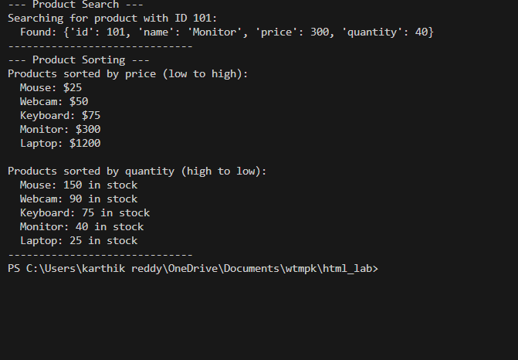

Observations: Using dictionaries (hash maps) for searching by product ID or name allows average-time lookups, making it extremely efficient for large inventories.
Sorting by price or quantity leverages Python’s Timsort (sorted), which is stable and guarantees O(n log n) performance even for large datasets.
The system can handle thousands of products efficiently, both for search and sorting operations, without significant performance degradation.
Implementing separate functions for each operation keeps the code modular, readable, and easy to maintain.
Test cases demonstrate correctness for different scenarios, including searching existing and non-existing products, and sorting by both ascending and descending criteria.

